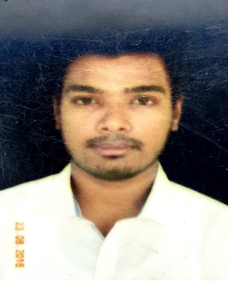CURRICULUM VITAE

# ANKIT SAHA

### Mobile No. : 7668333666

### E-mail : ankitsaha610@gmail.com

# OBJECTIVE

Electrical Professional possessing excellent technical knowledge and quick learner for any task delegated. Owning great leadership and management skills that will lead to form a performing persistent team that will grab innovative ideas and utilize it for perfection.

**EDUCATIONAL QUALIFICATIONS**

# 

Degree pursuing B. TECH in Electrical Engineering (currently in 8th semester)

Institute **O. P. JINDAL UNIVERSITY**, RAIGARH

# 

2015 Intermediate with (74%) from **DELHI PUBLIC SCHOOL** VARANASI

2013 High school with (72%) from **DELHI PUBLIC SCHOOL** VARANASI

# SKILLS SETS

* Ability to work in new and challenging environment, as well as deadlines drive environment
* Willingness to work in groups and ability to lead in group activities
* Willingness to learn new concepts & ideas involving new technologies with an ability to adapt quickly and effectively

# HOBBIES

* Playing Billiard
* Video Games

# ACHIEVEMENTS

* Received certificate of Summer Training under **INDIAN RAILWAY (ECR)**
* Actively participated in Industrial Visit to **JINDAL STEEL AND POWER PLANT,** RAIGARH
* Actively participated in **WAC** workshop of IOT conducted in **IIT BHU**
* Received certificate of Summer Training under **INDIAN OIL CORPORATION LIMITED**
* Completed a certificate course in **CCC**
* Completed a certificate course in **C**
* Completed a certificate course in **C++**
* Completed a certificate course in **JAVA**
* Acquired 1st position in **EDUCOMP SCHOOL QUIZ**

# PERSONALITY TRAITS

* Resilient
* Adaptability
* Leadership quality

# STRENGTH

* Better time manager
* Great grasping power

# WEAKNESS

* Over involved in tasks allotted
* Over conscious for work

PERSONAL DETAILS

Date of Birth 06/10/1997

Address H.NO. 183, New Mahal, Mughalsarai, Uttar Pradesh.

Language Known English, Hindi, Bengali, French

Marital Status Unmarried